3.4 Triggering the Build



This section will guide you to:

* Trigger a build in Jenkins

This guide has four subsections, namely:

3.4.1 Logging into Jenkins dashboard

3.4.2 Setting up a Angular Build Project in Jenkins for continuous integration

3.4.3 Pushing the code to your GitHub repositories

* Jenkins is installed in your practice lab. Refer to **DotNet Lab guide: Phase 4** for more information.

**Step 3.4.1:** Logging into Jenkins dashboard

* Jenkins is already installed in your practice lab.
* Open <http://localhost:8080> in the default browser.
* Provide username and password and click on **Login.**

**Step 3.4.2:** Setting up a Angular Build Project in Jenkins for continuous integration

* Open Jenkins dashboard page on <http://localhost:8080>.
* Login as admin user.
* Go back to the Dashboard page.
* In the Dashboard page, click on **New Item** from the left bar.
* Enter name as **angular_build_triggered**, select **FreeStyle Project** andclick **Ok.**

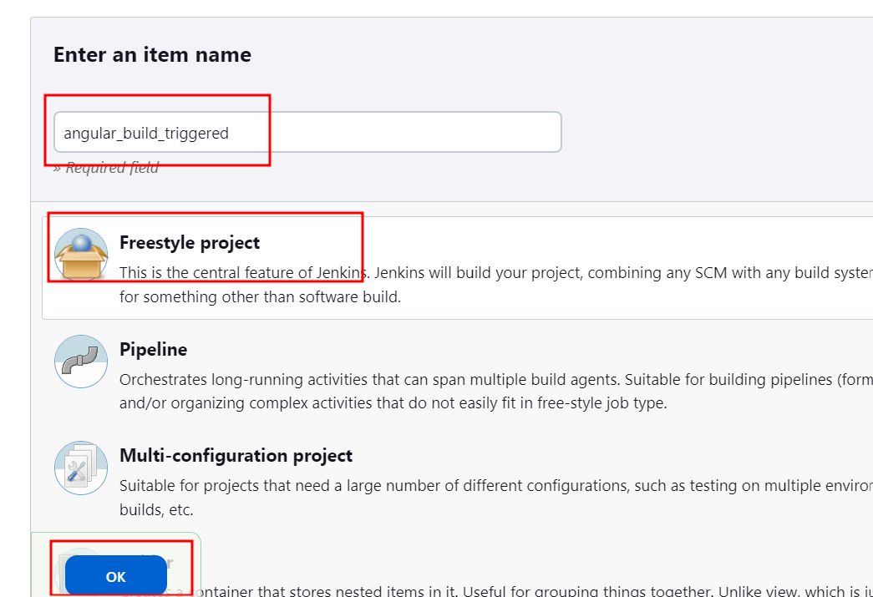

* This will open the Configuration screen.
* In the **General** tab enter a description of your choice.

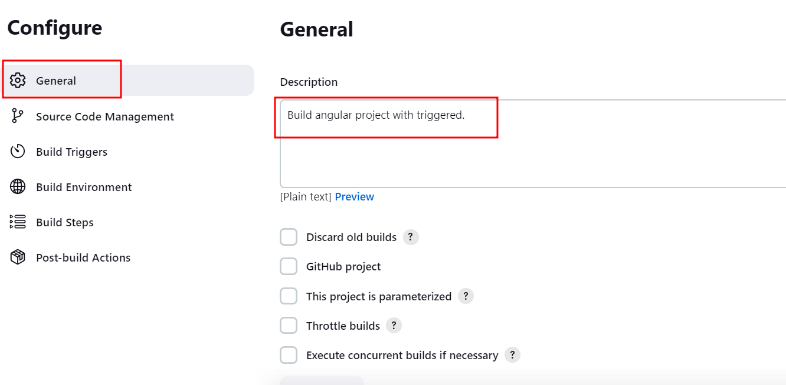

* Click **Source Code Management** tab and provide git url**.**

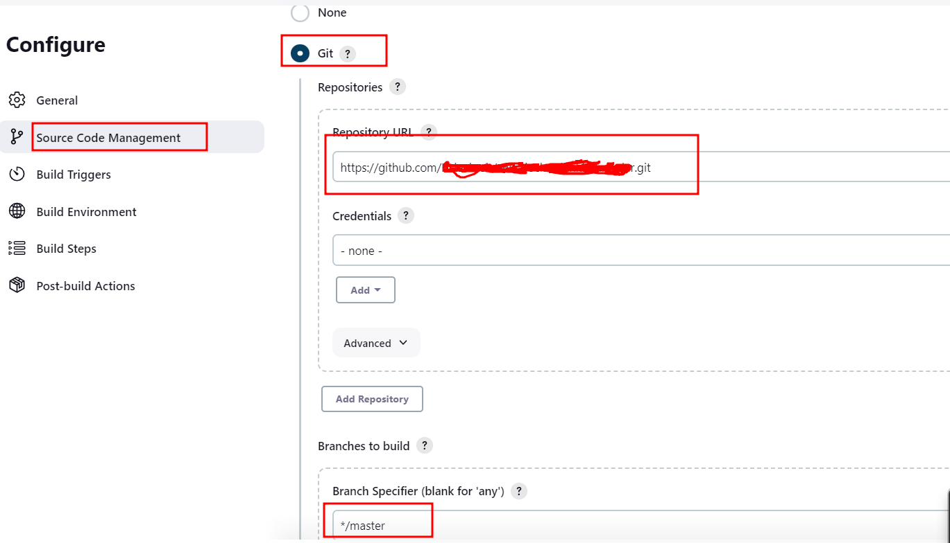

* Select Build trigger option

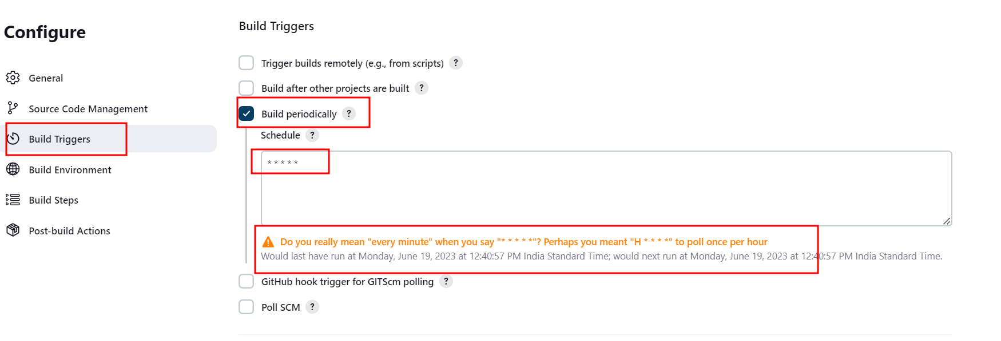

* This job execute again and again after every 1 minute. But real time scenario you can use other time options Crons job Click on? option.
* Click **Save.**
* From the left bar, click **Build Now** to build the project. This will generate a build in the Jenkins workspace. Once the **Build Number** is displayed click on it to see the workspace.

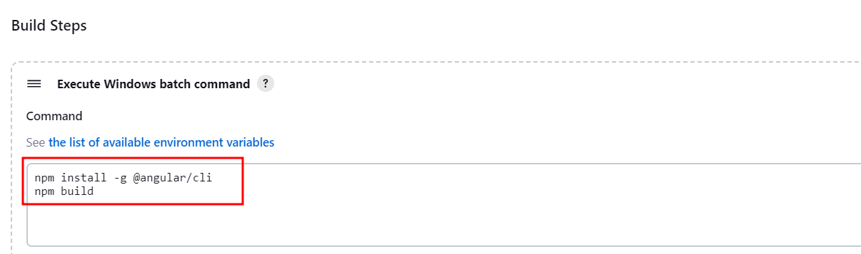

**Step 3.4.3:** Pushing the code to your GitHub repositories

Open your command prompt and navigate to the folder where you have created your files.

cd <folder path>

Initialize your repository using the following command:

git init

Add all the files to your git repository using the following command:

git add .

Commit the changes using the following command:

git commit -m “Changes have been committed.”

Push the files to the folder you created initially using the following command:

git push -u origin master